**Batch: T5**

**Practical No. 6**

**Title of Assignment:Study and implementation of ReactJs.**

**Student Name: Trishul Balaso Patil**

**Student PRN:22510051**

**Problem Statement 1: To-do List Application with State Management**

**•**

**Build a simple To-do List application that allows users to add, remove, and mark**

**tasks as completed.**

**The app should have a responsive user interface that works well on both desktop**

**and mobile devices.**

**Users should be able to input a task, which will be added to the list.**

**Each task should have a checkbox to mark it as completed.**

**Users can remove tasks from the list.**

**Use React hooks like useState for state management.**

**Add options to filter tasks based on completion status (e.g., all, completed, active).**

**Break down the Todo List into multiple components, like TaskList, TaskItem,**

**AddTaskForm, etc.**

**The app should display appropriate error messages.**

**The candidate should use appropriate error handling and validation to ensure that**

**the application is robust and user-friendly.**

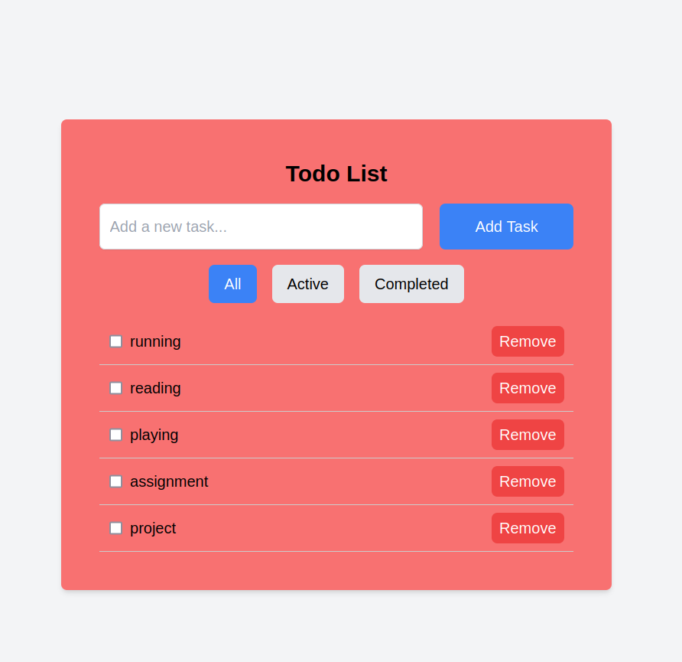**R**

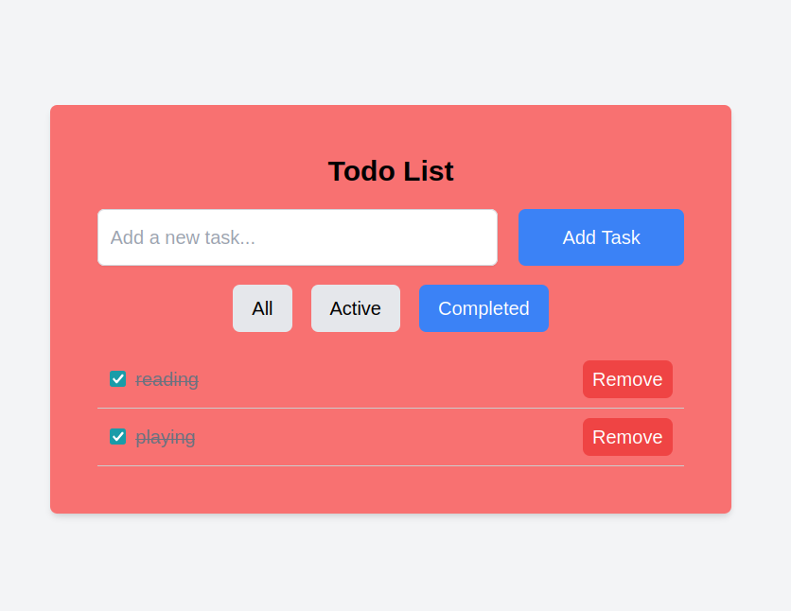**t**

**Problem Statement 2: Simple E-commerce Cart System**

**Requirements**

**•**

**Develop a small e-commerce application where users can browse products and add**

**them to a shopping cart.**

**Display a list of products with details like price, name, and image.**

**Users can add products to a shopping cart.**

**The cart page shows all selected products and their total price.**

**Users can remove items from the cart or adjust the quantity.**

**Add filtering options (e.g., by price, category) and sorting (e.g., low-to-high, high-to-**

**low).**

**Add routing to navigate between different pages, like the product list, cart, and**

**checkout pages.**

**On clicking a product, navigate to a detailed view of that product.**

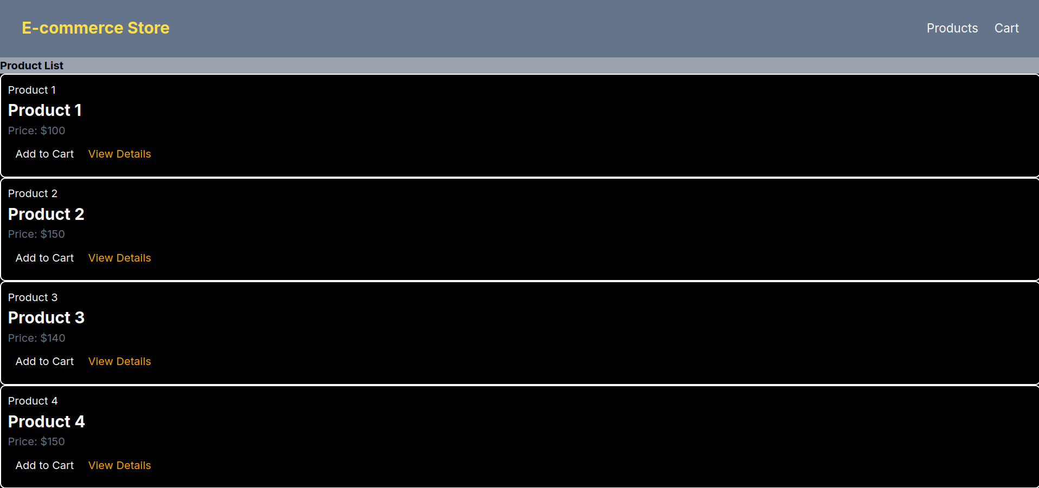

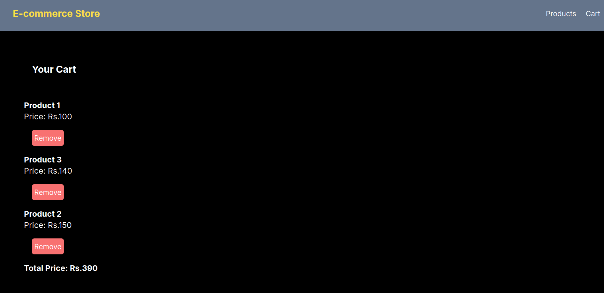

**Problem Statement 3: User Authentication with React Context API**

**Requirements**

**Create a login form that checks for hardcoded user credentials.**

**If authenticated, the user can see a personalized dashboard.**

**Allow the user to log out, which resets the context state.**

**Use React Router for navigation between login and dashboard pages.**

**Protect certain routes (e.g., dashboard) so that only authenticated users can access**

**them.**

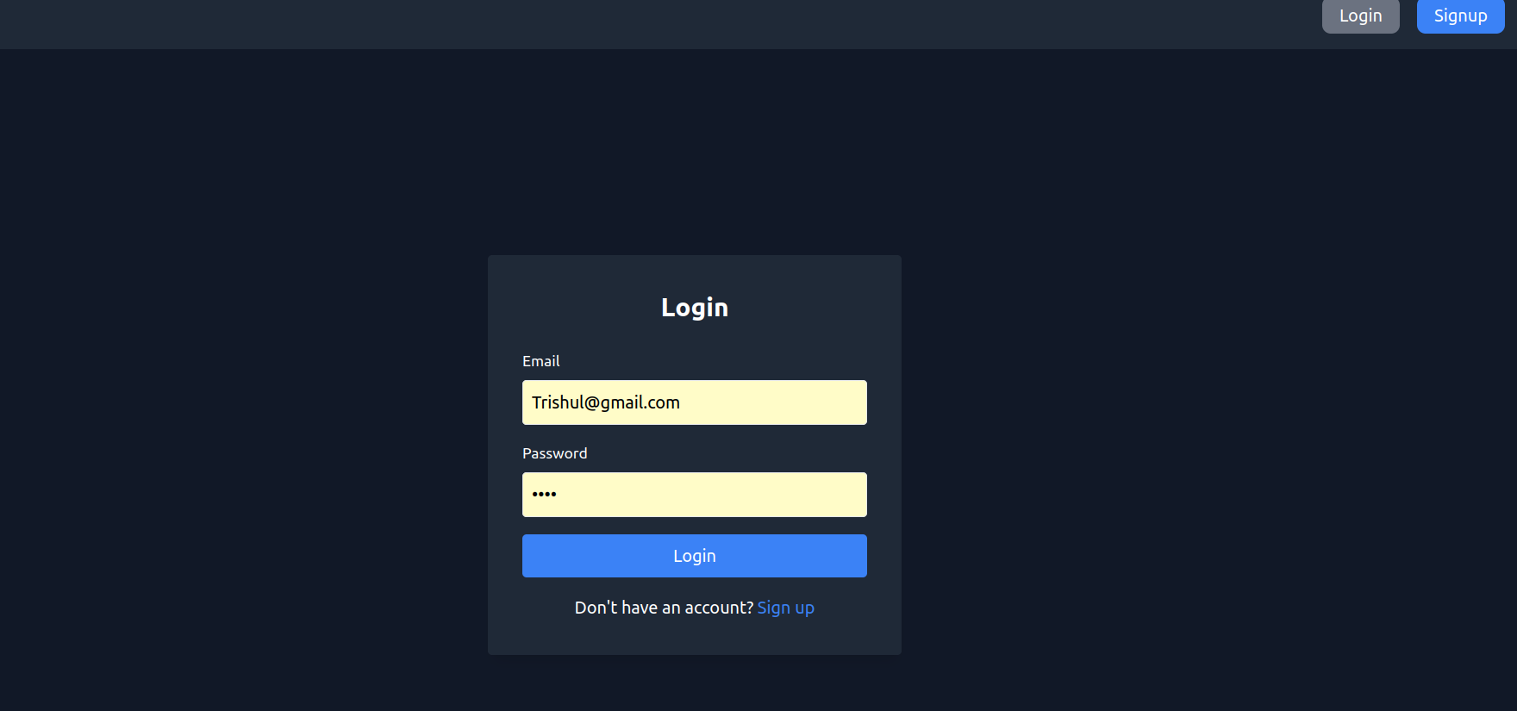

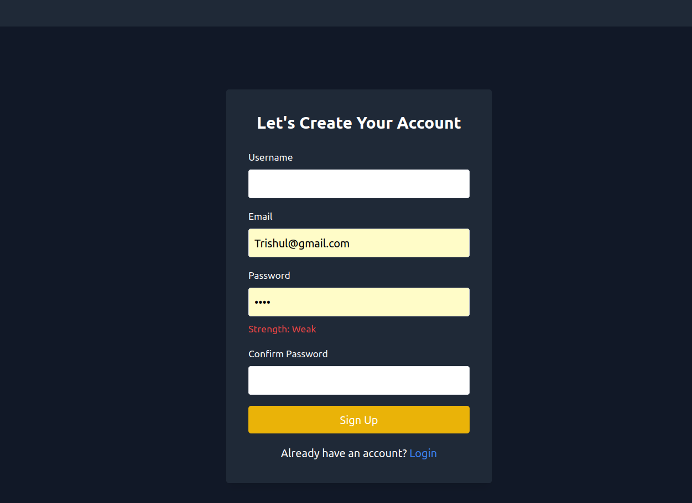**T**

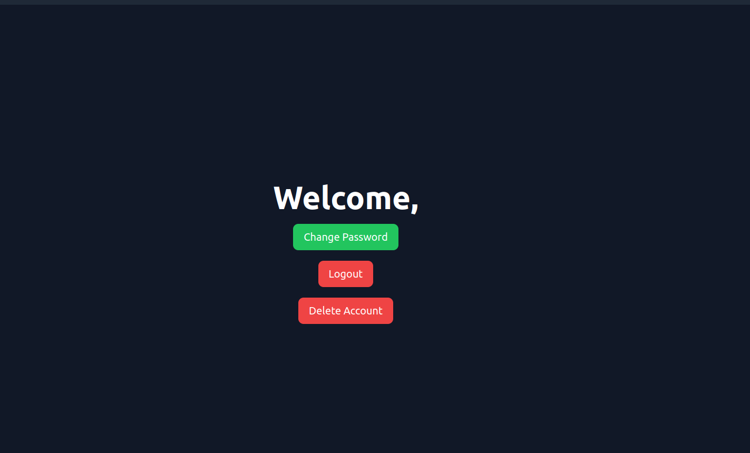**t**

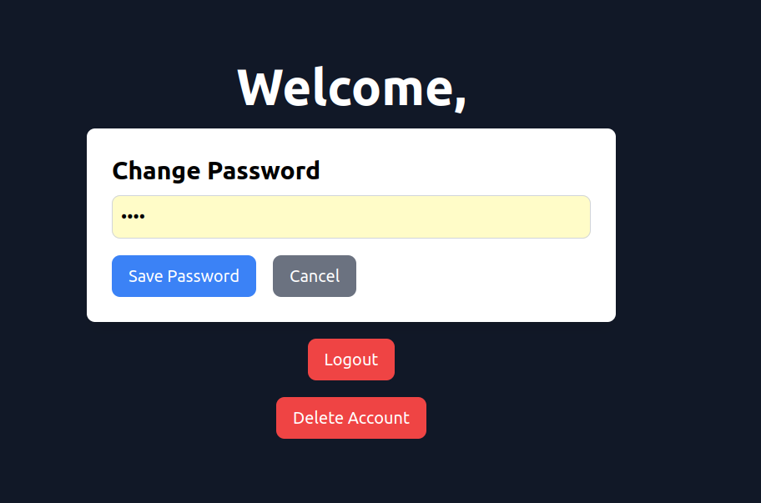**r**

